How to set variables for the Jenkins Job:

Jenkins can have 3 types of variables:  
1. Local variables

2.Globla variables

3.Predefined variables

**How to set Local variable:**

**Step-1:**

Login into Jenkins [**http://54.162.161.235:8080/**](http://54.162.161.235:8080/) **{IP address will be changed}**

**Step-2:**

Click on new Job and provide jobname and select free style job.

And click on OK.

**Step-3:**

Note: it will redirect to the configuration page.

1.provide the job description

2.Click on Build steps.

3.Select shell script

4.provide some steps with local variable.

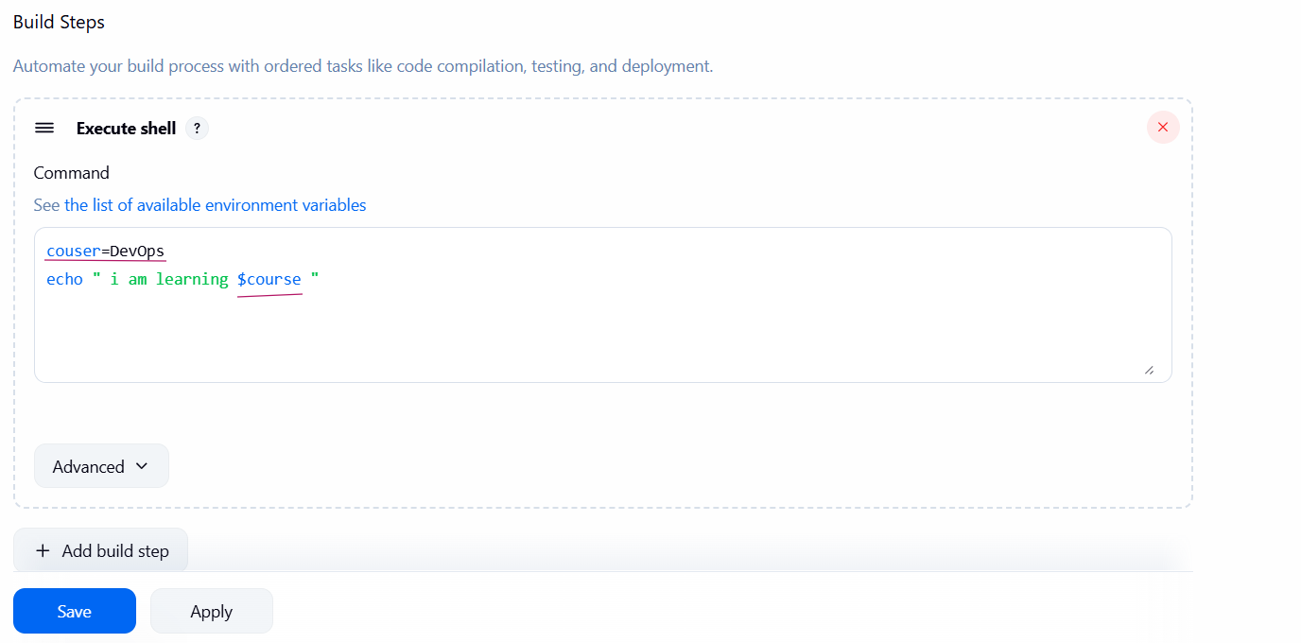

5.apply and save.

6.Click on Build Now and job will be create .

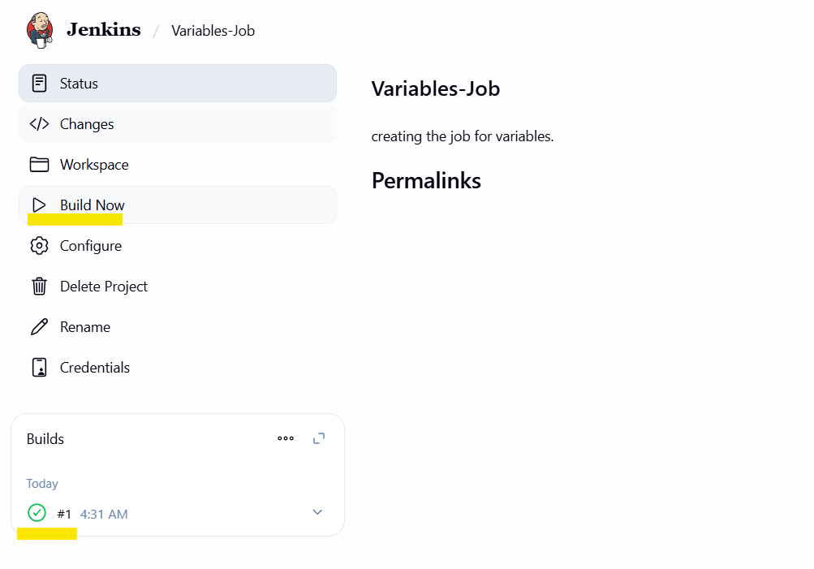

7.Click on console output to check the logs of the execution of job.

**Step-4:**

Login into Jenkins server and check the job output:

$ cd /var/lib/jenkins/workspace

$ ls

Here you can find the job folder.

**How to set global variable:**

**Step-5:**

1. Same process to create job what we followed above.
2. Click on settings button to create global variable

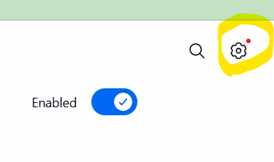

Click on System 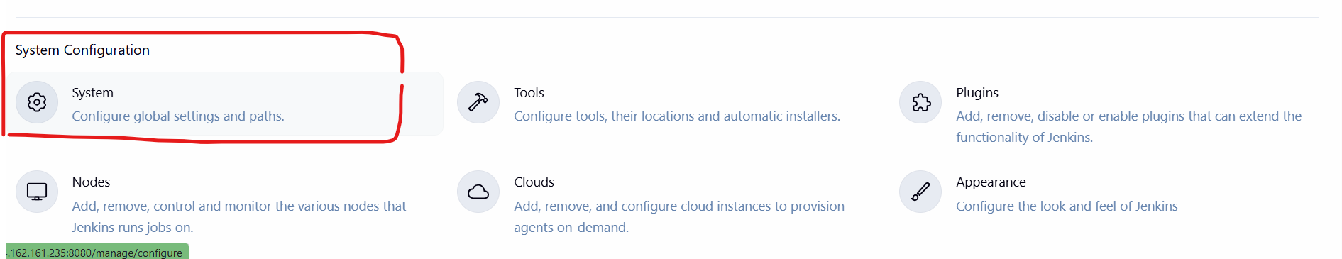

1. Go to Global properties >>> select environment variables >>add
2. Provide the variable along with value
3. Then this will applicable for all jobs globally.

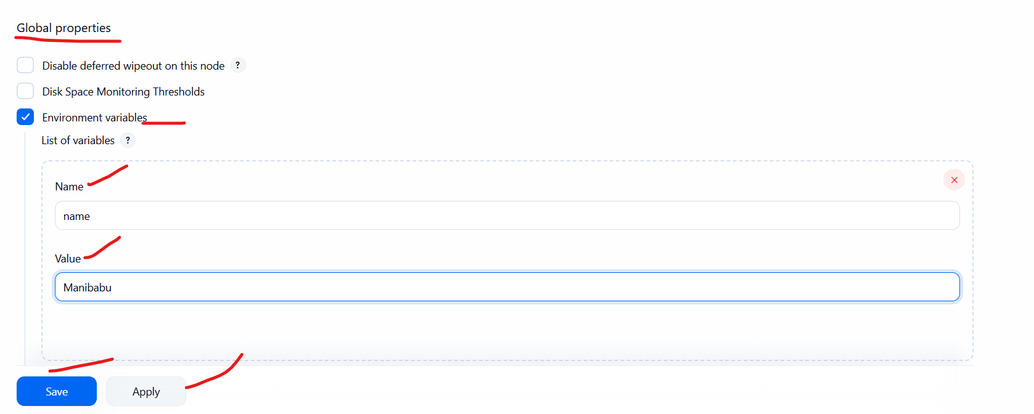

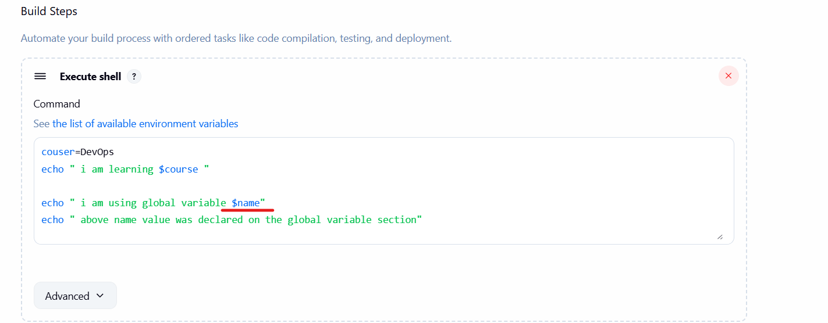

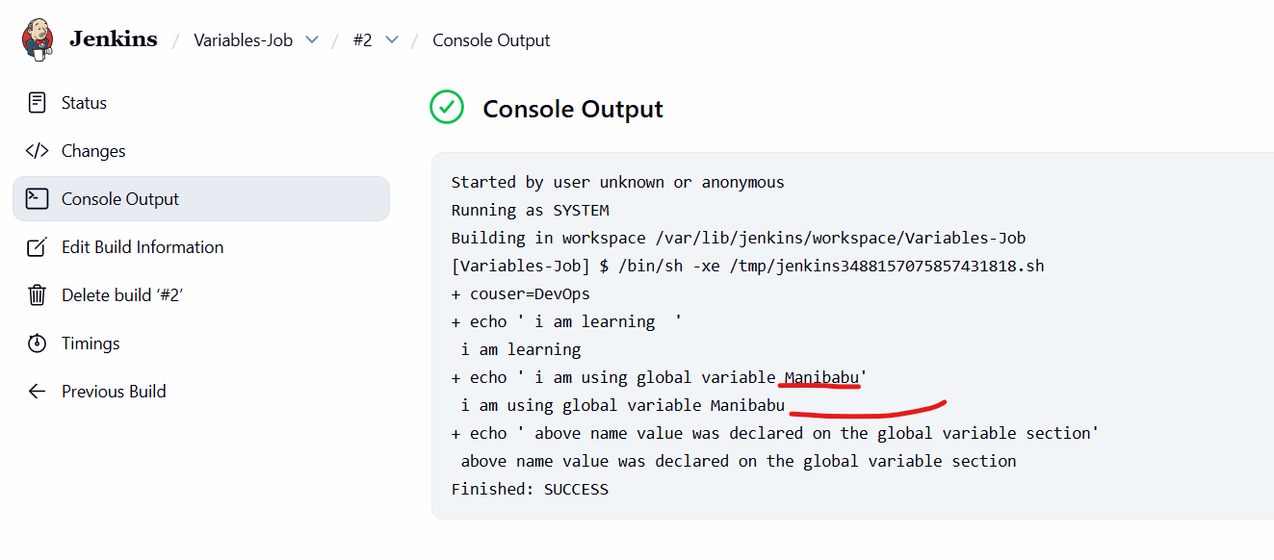

How to set Predefined variable:

**Step-6:**

Click on list available environment variable then you will find the predefined variables**.**

